HBase
- Data Model
Table is a sparse, distributed, persistent multidimensional sorted map, which is indexed by a row key, column key, and a timestamp; each value in the map is an uninterpreted array of bytes.
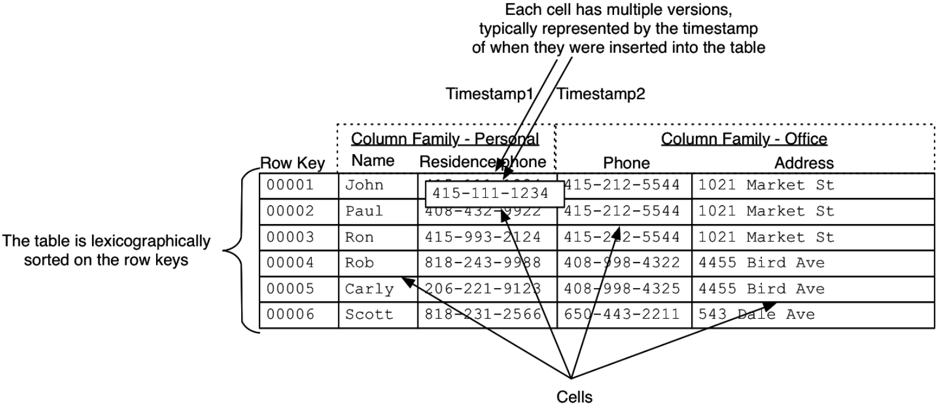
The rows are sorted based on the row keys. Column families also impact the physical arrangement of data stored in HBase. For this reason, they must be defined up front and are not easily modified. Each row in a table has the same column families. The table in HBase consisting of two column families, Personal and Office, each having two columns. Data within a column family is addressed via its column qualifier, or simply, column. The entity that contains the data is called a cell. Values within a cell are versioned, which by default is the timestamp of when the cell was written.
近似化表示：
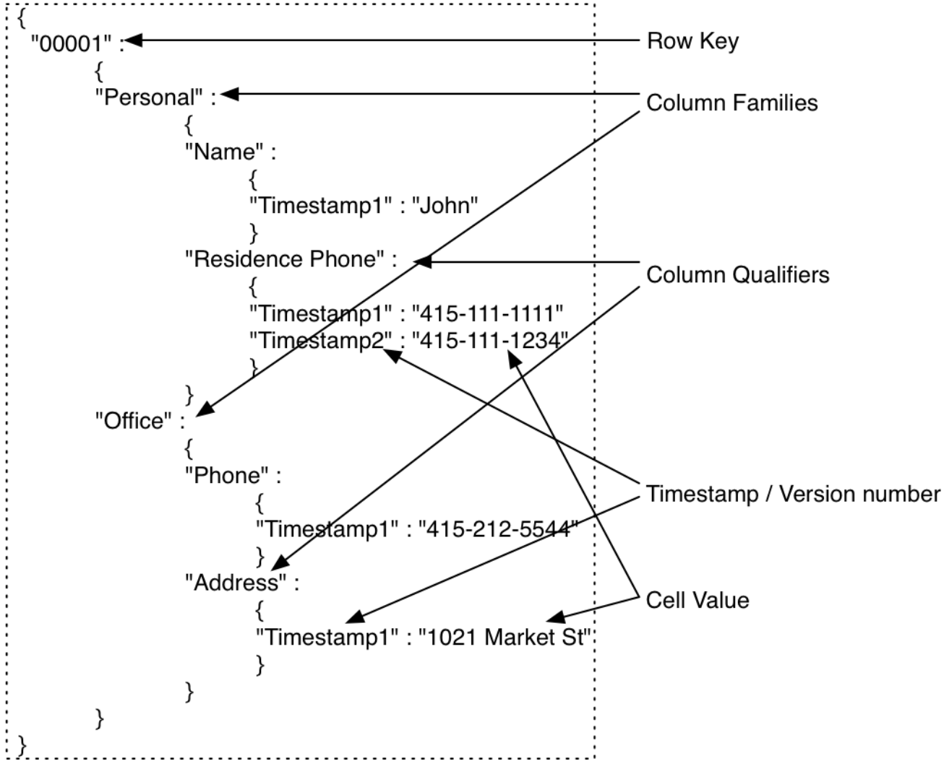
Key Concepts
- Everything in HBase tables is stored as a byte[]. There are no types.
- Each region in the table is responsible for a part of the row key space and is identified by the start and end row key. Atomicity is guaranteed only at a row level.
- Column families have to be defined up front at table creation time. Column qualifiers are dynamic and can be defined at write time. They are stored as byte[] so you can even put data in them.
- HBase’s API for data manipulation consists of three primary methods: Get, Put, and Scan.
- Architecture

- Maintenance

